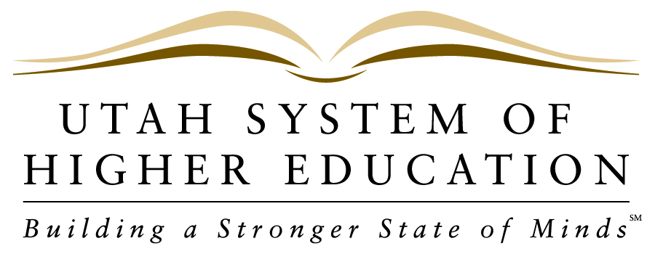 NEWS RELEASE
_____________________________________________________________________________________________

FOR IMMEDIATE RELEASE
Contact:Pamela Silberman, Director of Communications
Office: 801.321.7110
Cell: 801.633.8177
Email: psilberman@utahsbr.edu

October 4, 2012

Regents Announce Finalists for Weber State University President

SALT LAKE CITY – The State Board of Regents announced Thursday the four finalists who will interview for the position of President of Weber State University in Ogden, Utah. The Presidential Search Committee conducted a national search and considered nearly 50 potential candidates. The finalists were recommended after an in-depth screening process and several days of comprehensive interviews.

“We have received a great deal of public input over the past few months, and now the Weber State Presidential Search Committee is pleased to advance the names of these four highly qualified finalists,” said Search Committee Chair, Regent Bob Marquardt. “The support of Weber State’s faculty, students and staff, along with the larger community has been tremendous throughout this search process. We look forward to speaking with these candidates further as the Board of Regents moves closer to finding a new leader for Weber’s diverse and highly engaged campus community.”

After months of soliciting input through public meetings, online submissions and the 22-member Presidential Search Committee, the Board of Regents will interview the following finalists (in alphabetical order):

Dr. Kathryn Cruz-Uribe, Provost and Vice President for Academic Affairs at California State University, Monterey Bay since 2007. Dr. Cruz-Uribe is currently second-in-command at Cal State Monterey Bay and leads all aspects of the academic operations at the university. In this position, Dr. Cruz-Uribe has overseen the development and implementation of a new University Strategic Plan and a new five-year Academic Plan. She previously served as Interim Dean and then Dean of the College of Social and Behavioral Sciences at Northern Arizona University. Dr. Cruz-Uribe joined the faculty of Northern Arizona in 1989 as an Assistant Professor and was promoted to full Professor in 1998. She received the President’s Medal for Outstanding Administrator from Cal State Monterey Bay in 2011 and received an Outstanding Teaching Award from Northern Arizona in 1996. Dr. Cruz-Uribe has published more than 45 scholarly articles and books. She graduated magna cum laude with a BA in Anthropology and Art from Middlebury College and holds both an MA and a PhD in Anthropology from the University of Chicago.

Dr. Kim Hunter Reed, Chief of Staff of the Louisiana Board of Regents, since 2008. In this position, Dr. Reed oversees initiatives to strengthen completion, improve accountability and increase quality within Louisiana’s public institutions of higher education. She spent five years at Southeastern Louisiana University where she was Executive Assistant to the President and Interim Vice President for Student Affairs. Dr. Reed previously served as Deputy Commissioner for Public Affairs for the Louisiana Board of Regents and Executive Vice President for the University of Louisiana System. In service to two governors of the State of Louisiana, Dr. Reed served as Deputy Chief of Staff, Director of Policy and Planning, and Press Secretary. She is a senior higher education consultant for HCM Strategists in Washington, DC,, and is actively engaged in national and state higher education policy issues. Dr. Reed holds a BA in Broadcast Journalism and an MPA from Louisiana State University, and a PhD in Higher Education Policy from Southern University and A&M College. She also completed a program in education management and leadership at Harvard University.

Dr. Michael K. Thomas, President & CEO of the New England Board of Higher Education since 2008. Dr. Thomas has been with the New England Board of Higher Education, since 2002, also serving as Senior Director of Policy and Research and Senior Vice President. He previously worked at Lesley University in Cambridge, Mass., as Executive Assistant to the President and Assistant Professor, and as Coordinator of Institutional Research and Analysis. He is the author of over 30 published articles and reports. Dr. Thomas graduated with honors from Brigham Young University, earning a BA in philosophy. He earned an MA in Higher Education & Student Affairs Administration from Teachers College at Columbia University, and both a Master and Doctor of Education in Administration, Planning & Social Policy from Harvard University. Dr. Thomas also holds an MBA from Boston University. He served as trustee and vice-chair of Worcester State University (Massachusetts) and was a 2008 Millennium Leadership Initiative Fellow with the American Association of State Colleges and Universities (AASCU).

Dr. Charles A. Wight, Associate Vice President for Academic Affairs & Dean of the Graduate School at the University of Utah, since 2006. In this position, Dr. Wight supports graduate students throughout the institution and promotes academic quality through a rigorous system of program reviews. Dr. Wight came to the University of Utah in 1984 as an Assistant Professor of Chemistry, becoming a full professor in 1993. Since then he has held numerous positions at the U, including Associate Dean for Undergraduate Studies and Assistant Vice President for Continuing Education. Dr. Wight received the R.W. Parry Teaching Award in Chemistry in 2006 and was named a fellow by the American Association for the Advancement of Science in 1994. He was also an Alfred P. Sloan Research Fellow from 1990-1994. Dr. Wight has filed three patent applications and published 150 peer-reviewed articles and two books. He graduated Phi Beta Kappa with a BS in Chemistry from the University of Virginia and received a PhD in Chemistry from the California Institute of Technology, where he received the best dissertation award.

The finalists will be on the Weber State Ogden campus Monday, October 8, 2012, to meet privately with groups representing faculty, staff, students, and administration. On Tuesday, October 9, the Board of Regents will interview the finalists in a closed session. The Board may convene a public meeting at 4:30 p.m. that day to select the President. They may, however, convene at another time, which will be announced at a later date.

A complete listing of the campus group representatives is available on the WSU Presidential Search website at weber.edu/presidentialsearch/timeline.html. As an ongoing part of the selection process, the Presidential Search Committee invites public input regarding these finalists. The public is welcome to submit commentary via the WSU Presidential Search website at weber.edu/presidentialsearch/comment.html

About The Utah System of Higher Education: USHE includes all of Utah’s eight public colleges and universities: The University of Utah, Utah State University, Weber State University, Southern Utah University, Snow College, Dixie State College, Utah Valley University and Salt Lake Community College. For more information on the Utah System of Higher Education, visit our website at http://www.higheredutah.org.

###

