

**UTAH COLLEGE APPLICATION WEEK**

**SITE COORDINATOR MANUAL**

**2021 EDITION**





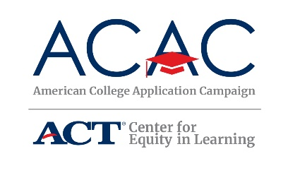

© 2021 Utah System of Higher Education. All rights reserved.

**Table of Contents**

**Executive Summary**

**UCAW Key Topics** **4**

**Section 1: Introduction**  **6**

Welcome & Background: Utah College Application Week 7

**Section 2: Site Coordinator Planning 8**

Site Coordinator Responsibilities  9

Site Coordinator Calendar Check List 10

Building a Team 16

Organizing an Event 18

Additional Resources 20

**Section 3: Pre-Event Awareness and Activities 21**

Best Practices: Creating a College Going Culture/UCAW Awareness 22

College Focused Activities in the Classroom 22

Communicating to Students, Families, Community Organizations 23

**Section 4: Media and Public Relations** **27**

Media Information and Guidelines 28

Examples of Media & Social Media 28

Media/PR Tips 30

**Section 5: During UCAW**  **31**

Update: UCAW Collateral 32

Student Instructions on Day of Event 32

Volunteer Tasks 32

Application Fee Waivers 33

Data Tracking 33

UCAW Event Sign-Out Sheet 34

**Section 6: Post Event and Follow Up**  **35**

After Your College Application Program 36

College Decision Day 36

Social Media Surrounding National Decision Day 38

**Appendix 39**

Student Instructions Handout 40

Senior Year Timeline to College Readiness 41

College Deadlines Handout 42 FAFSA and UCAW Survey QR Codes 43

FSA ID Registration Handout 44 UCAW Poster 45

“Ask Me” Poster 46

College Bingo Activity 47

Online Scavenger Hunt Worksheet 48-50

Student Interest Survey 51

College Application Worksheet 52

Student, Family and Community Letters 53-55

Volunteer Thank You Letter 56

**Executive Summary**

# Utah College Application Week and the American College Application Campaign

# The goal of Utah College Application Week (UCAW) is to provide every high school senior at our partner schools with the opportunity to complete at least one college or university application during the school day. Special focus is placed on students who will be the first in their families to attend college, on low-income students, and on students who may not have otherwise considered applying to college.

# UCAW is part of the American College Application Campaign and the ACT Center for Equity in Learning (ACAC/ACT). ACAC/ACT is a national effort to increase college access through sharing ideas, developing best practices, and providing technical assistance for implementation of a college application event.

# This manual is intended for high school site coordinators (typically school counselors or administrators) to use in planning and implementing UCAW events at their school.

**Some of the key topics the school team should discuss are:**

* Specifics from the UCAW checklist (see page 9)
* Responsibilities of school team members
* Date(s) for the kickoff events, the week you have selected for your UCAW in October, FAFSA nights, and College Decision Day in May
* Communication strategies for students, parents, school staff, and the community including:
  + Letters
  + Automated phone calls
  + Press releases
  + Photo releases
  + Social media accounts, including hashtags
  + Marketing
  + Funding to pay application fees for students in need
* Pre-application events to ensure students are prepared
* Pre-application excitement—creating or enhancing a college-going culture throughout the school
  + College and university posters in hallways/door decorating contest
  + FSA ID/FAFSA completion
  + Assembly/kick-off event
  + Peer-to-peer assistance (SBO’s, LIA, etc.)
  + College-oriented lessons in regular classes
* Mayoral proclamation
* School district proclamation—leverage district administration for this task
* Recruiting volunteers for the initiative
* Engaging volunteers
  + District/school rules regarding volunteers
  + Training
* Including underclassmen in the program
  + School-wide awareness activities
* Promoting application events to seniors
  + Preparation
  + Expectations
* Evaluation and data collection
* Application follow-up—ensuring the college and financial aid processes are completed
* May College Decision Day activities

**After your College Application Week event**, your school team should meet to debrief the successes and challenges of the current year’s initiative. By quickly assessing what worked and what areas need improvement, your school team can get a jump-start on planning for the following year’s program and create an action plan to work with students who still need to finish the college application and financial aid application processes.

# For any questions regarding the information included in this document or about Utah College Application Week, please contact the UCAW State Coordinator, Lisa Molina, at [lisa.molina@ushe.edu](mailto:lisa.molina@ushe.edu) or [ucaw@ushe.edu](mailto:ucaw@ushe.edu).

**American College Application Campaign**

[equityinlearning.act.org/acac](https://equityinlearning.act.org/acac/)

**Utah System of Higher Education**

ucaw@ushe.edu

[ushe.edu/utah-college-application-week](http://ushe.edu/utah-college-application-week)

Section 1:

Introduction

Welcome to Utah College Application Week!

The purpose of this initiative is to help high school seniors navigate the college admissions process and ensure each high school senior submits at least one college admissions application during the school day. There is no participation fee or cost for schools to participate in UCAW, although success is heavily reliant on school buy-in and the ability of a site coordinator to absorb the hours required for planning and implementation.

As part of Utah College Application Week, schools should plan a FAFSA Completion Event to ensure students apply for financial aid as part of the admissions process. Lead-up events can assist students in registering for their FAFSA FSA ID. A celebration of College Decision Day in May is the final event in the cycle. Nationally, this is viewed as the 1-2-3 Step Approach.

**About our National Partners: ACAC/ACT**

The ACAC initiative began in 2005, run by a single GEAR UP program in Chatham County, North Carolina. By 2008, several other states had begun implementing a College Application Campaign. In 2014, ACAC was integrated into all fifty states. Utah joined the initiative in November of 2013, with a pilot program of eight high schools in three districts with 2,300 students. Last year, 124 Utah high schools in 32 districts participated, from Logan to Blanding and Tooele to Moab. More than twenty-four thousand seniors completed college applications as part of UCAW last fall.

**As an ACAC partner state, Utah commits to tracking completed college applications statewide. Tracking college applications and data in each school becomes vital to the sustainability of this program.**

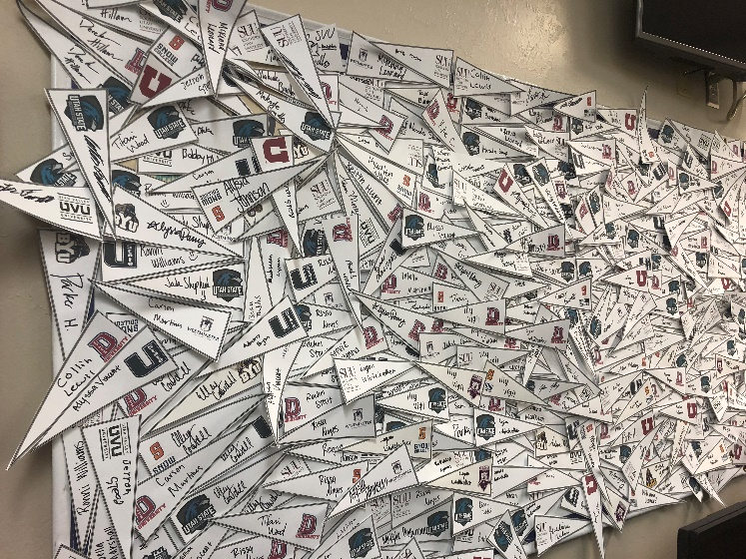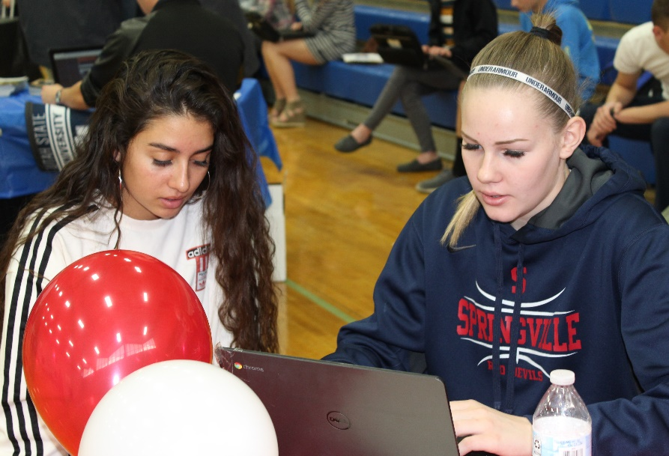

Section 2:

Site Coordinator Planning

Responsibilities of the Utah System of Higher Education

The state UCAW coordinator will provide national and statewide coordination, overall planning, timelines, collateral, tracking/reporting data, and implementation for this program at a state level.

USHE will create training materials for successful implementation and provide links to UCAW resources on the USHE website: [ushe.edu/utah-college-application-week](https://ushe.edu/utah-college-application-week/).

Responsibilities of Participating High Schools/Districts

Participating schools are expected to hold their UCAW event during **October**, which is the State of Utah’s official College Awareness & Application Month.

Many schools have found success with a two-week model: one week for building awareness and excitement, followed by the actual application week. Other schools are small enough that their College Application Week is really just one day.

We encourage site coordinators to implement UCAW in a way that will work with their individual school demographics, staff, volunteers, geography, and resources. The success of UCAW is based on the flexibility to tailor the program to best serve your school schedule, school culture, and student population.

**Site Coordinator Role & Responsibility**

Each high school will identify a site coordinator, typically a counselor or an assistant principal, who will be responsible for implementing the program at their school.

**Site coordinators are responsible for:**

Registering their schools to participate at [forms.gle/LZPbGdeD2uerrses8](https://forms.gle/LZPbGdeD2uerrses8).

**Note: To avoid duplicate responses, please reach out to** [**lisa.molina@ushe.edu**](mailto:lisa.molina@ushe.edu) **if you need to confirm your UCAW dates.**

**If you already registered your school and want to change your date(s), please email** [**lisa.molina@ushe.edu**](mailto:lisa.molina@ushe.edu) **so we can keeo college admissions offices informed about your school’s UCAW dates and times.**

Recruiting and training all volunteers for their program from school teachers or staff, parents/PTA, alumni, community groups, or local businesses

**☐** Scheduling the program to occur **during the school day** to give all seniors the opportunity to complete and submit one viable college application, with a special focus on engaging first-generation students, low-income students, and students who may otherwise not apply to college.

Coordinating with college representatives and college/university admissions offices

Collecting and reporting data back to USHE, including the number of students participating and the number of applications submitted (usually calculated by the number of transcripts sent). This includes encouraging students to fill out exit surveys after completing their college application(s).

Note: *Institutional memory is valuable! This is why we ask that interns and other temporary employees be reserved for assisting in the planning and implementation of UCAW events and that the primary site coordinator be either the school’s college access adviser or a permanent school employee.* Temporary employees, like interns, are essential to accomplishing UCAW events and maintaining rapport with students and will be an excellent support to a permanent school employee on site.

**Site Coordinator Check List**

|  |  |  |  |
| --- | --- | --- | --- |
| **BEFORE COLLEGE APPLICATION WEEK** | | | |
| **Date Completed** | **Recommended Completion Date** | **Task** | **Notes** |
|  | May-Aug | Confirm your high school’s participation in 2021 UCAW |  |
|  | May-Sept | Register your school as a partnering UCAW school | [forms.gle/LZPbGdeD2uerrses8](https://forms.gle/LZPbGdeD2uerrses8)  After you register, you will receive a confirmation email with your response. Within this email, you will have the option to edit at any time. If you have questions, please contact Lisa Molina at [lisa.molina@ushe.edu](mailto:lisa.molina@ushe.edu). |
|  | May-Sept | Establish a school site team; plan first meeting date (teachers, SBOs, administrators, parents/families, Local College Access Networks, etc.) |  |
|  | May-Sept | Determine calendar/timeline for your site’s programming events |  |
|  | May-Sept | Add Utah College Application Week to your school’s master calendar |  |
|  | May-Sept | Reserve computer labs facilities for UCAW |  |
|  | Aug-Sept | Review Site Coordinator Manual; review and save Site Coordinator Appendix |  |
|  | May-Sept | Review requirements for FAFSA Completion event, including date and coordination. | For additional information, review the FAFSA Coordinator manual |
|  | May-Sept | Host site team meeting and determine meeting schedule |  |
|  | May-Sept | Secure options for assisting with application fees (donations from local businesses, school district foundation, etc.) |  |
|  | Aug-Sept | Review awareness activities in this manual and the Appendix; determine which will be used at your school to make the event fun and exciting |  |
|  | **Sept. 28** | **Attend Virtual Ed Insights K-12 Edition-Paying for College (Tuesday, Sept. 28)** |  |
|  | Aug-Sept | Encourage students to research colleges and universities |  |
|  | Aug-Sept | Determine schedule for the event, including what groups or classes of seniors will participate at what time and in what room |  |
|  | May-Aug | Contact the mayor’s office to have your College Application Week events proclaimed by the city; coordinate this request with other participating schools in your city. See Appendix for a draft proclamation. |  |
|  | Aug-Oct | Discuss possible connections between classroom lessons or activities and the College Application Week program with teachers. |  |
|  | Sept-Oct | Determine process for each eligible senior to register for a FAFSA login (FSA ID). *Social Security Number required* |  |
|  | Aug-Sept | Recruit volunteers. If your school has criminal background check requirements, be sure to complete this process |  |
|  | Sept | Communicate the opportunity to students, parents, families, and the community; this is a great way to recruit volunteers. Sample letters are in the Appendix. |  |
|  | Aug-Sept | Plan awareness activities for students in grades 9-11 |  |
|  | Sept | Finalize process for fee waivers, how to pay for application fees with donated/district funds, how to select students for donated fee waivers, etc. |  |
|  | Aug-Sept | Check [ushe.edu/utah-college-application-week](https://ushe.edu/utah-college-application-week/) for updated information on application websites, forms, formats, and requirements of Utah’s colleges and universities |  |
|  | Sept | Plan and prepare publicity efforts to get the word out about the event in your community; see Appendix for sample press releases, social media posts, posters, door decorating contests, etc. | Please send copies of all press releases or PR articles to [ucaw@ushe.edu](mailto:ucaw@ushe.edu). |
|  | Aug-Sept | Confirm event dates with school and district technology team to ensure computer labs are ready to go; **ensure Utah’s college and university websites are not blocked, and there are no firewall issues** |  |
|  | Oct | Encourage teachers to relate lessons to College Application Week and discuss the importance of college in their classes |  |
|  | Sept-Oct | Send letters to local businesses asking for prizes/donations to be used during UCAW; see Appendix for sample letter |  |
|  | Sept | Send out any final communications to students and parents regarding College Application Week; see Appendix for templates of letters and postcards |  |
|  | Sept | Ensure all your supplies are ready: name tags for volunteers,  sign-out sheet, survey, FAFSA handout, student folders, etc. |  |
|  | Sept | Finalize volunteer participants, schedule, and individual responsibilities; see Appendix for examples |  |
|  | Aug-Sept | Confirm publicity and/or attendance of guest speakers for all College Application Week events. |  |
|  | Aug-Sept | Train all participating staff and volunteers on application completion and FAFSA login (FSA ID) registration. |  |
|  | Aug-Sept | Train all volunteers in the processes for your school’s events; ensure all have any  necessary security clearance to participate |  |
|  | Sept | Confirm seniors all have completed their college application checklist |  |
|  | Sept-Oct | Remind all staff of UCAW schedule and activities; request they wear college clothing throughout the event and decorate classrooms with college materials or discuss their college experiences in class |  |
|  | Sept-Oct | Send a message to all volunteers with final schedule, dates, times, and other reminders; schedule volunteer orientation meeting for the morning of events, if necessary |  |
|  | Sept-Oct | Alert local media about events |  |
| **OCTOBER: DURING COLLEGE APPLICATION WEEK** | | | |
| **Date Completed** | **Recommended Completion Date** | **Task** | **Notes** |
| *\*\*UCAW activities can take place any time during October. Below is a recommended timeline. Please fill in dates that will line up with your school’s UCAW schedule.* | | | |
|  |  | **Week before UCAW: AWARENESS WEEK!** |  |
|  | Oct 1 | Email and phone blasts to parents; see Appendix for examples |  |
|  | Oct | Remember to take pictures during UCAW events and upload to Facebook, Twitter, or Instagram and use hashtags #iApplied, #CollegeBound and #UCAW |  |
|  | Oct | Awareness activities for 9-11th graders |  |
|  |  | **APPLICATION WEEK!** |  |
|  | Oct | Welcome volunteers and make sure they are all clear on their roles and responsibilities |  |
|  | Oct | **Students should register for their FAFSA FSA ID during College Application Week** | **REQUIRED** |
|  | Oct | **Students should sign in to events using pre-printed handout** | **REQUIRED** |
|  | Oct | Ensure each senior receives a packet of information, including the “What’s Next” document and information on FAFSA completion |  |
|  | Oct | If possible, send transcripts to colleges and universities immediately; utilize electronic transcripts whenever possible to reduce time and cost. |  |
|  | Oct | **Each student must complete and turn in a UCAW student survey (provided by USHE)** |  |

|  |  |  |  |
| --- | --- | --- | --- |
| **AFTER COLLEGE APPLICATION WEEK** | | | |
| **Date Completed** | **Recommended Completion Date** | **Task** | **Notes** |
|  | Nov | Have a wrap-up meeting with your school team; discuss positives and things that went well; discuss things that could be improved, and brainstorm ways to eliminate those issues next year |  |
|  | Nov | Thank your volunteers; see Appendix for sample letter |  |
|  | Nov | Follow up with teachers, counselors, and other school administration and personnel to let them know the successes of your event |  |
|  | Nov | Communicate the program’s impact with local media; see Appendix for sample of post-event press release | **Send copies of media coverage to** [**ucaw@ushe.edu**](mailto:ucaw@ushe.edu)**.** |
|  | **Nov 8** | **Submit all requested information and data to Utah System of Higher Education: check-in sheets (electronically, please), student surveys, etc.** | **Lisa Molina at** [**lisa.molina@ushe.edu**](mailto:lisa.molina@ushe.edu) |
| **SPRING 2021** | | | |
| **Date Completed** | **Recommended Completion Date** | **Task** | **Notes** |
|  | Nov-May | Any follow-up FAFSA Completion events or programming. |  |
|  | March | Plan your school’s events and program for National Decision Day activities (May 1), recruit staff or volunteers. | **Share decision day date with Lisa Molina at** [**lisa.molina@ushe.edu**](mailto:lisa.molina@ushe.edu) |
|  | March-April | Advertise to students the importance of their decision to attend college in the fall and celebrate! |  |
|  | May | National Decision Day, May 1. Plan a small celebration, assembly, or lunchtime activity to celebrate seniors’ decision to enroll in college or university. |  |

**School Buy-In**

Based on feedback from previous UCAW campaigns, the schools with the most success during UCAW had strong support from school administration and district staff. Engaging teachers and other staff to help with awareness activities and application efforts also creates a more successful event.

**Key Elements**

High schools implementing a successful College Application Week event at their school will include the following as part of their initiative:

* Identify and gather a school team comprised of counselors, staff, and community members with support from the school administration and district.
* Reserve and use computer rooms or labs for students to use to complete their applications during UCAW events.
* Assist each eligible high school senior in registering for a FAFSA login (FSA ID) and linking the college application process to the financial aid piece by hosting at least one FAFSA Completion event in the fall.
* Engage local community organizations, families, and others through volunteer opportunities, informational letters, and advertising campaigns, or other marketing efforts.
* Follow up with students after the event to ensure the applications they submitted are complete, including official high school and Concurrent Enrollment transcripts, college entrance exam scores, payment of application fees, etc.
* Continue to create a college-going culture within your school through a variety of approaches—some suggestions and best practices are included in this guide.
* Create a celebration surrounding National Signing Day/College Decision Day during the first part of May. Read on for more information and ideas.

**Best Practices**

* Leverage support of the school team to ensure that students are prepared to participate in the event (planning pre-application activities, giving students the assignment to research the institutions to which they want to apply, making students aware of the information and resources required from home for their application such as Social Security Numbers, means to pay admission fees, etc.).
* Use student leaders or other peer-to-peer mentors throughout the process. Several other schools reported this as a very positive addition to their UCAW event.
* Solicit funds from businesses, community organizations, or district foundations to support students with financial needs to help with application fees, as well as other donations to be used as prizes and giveaways for students.

**Branding**

****UCAW is a statewide initiative linked to a national campaign, so although implementation is done at the school level, it is not a school-specific program. All school-produced documents should include the UCAW logo and copyright. As schools plan and execute their own advertising, marketing, and communication efforts, please include the UCAW logo in addition to any district or school logos, including on all letters or communications to students and parents, handouts, any printed posters, press releases, and thank you letters.

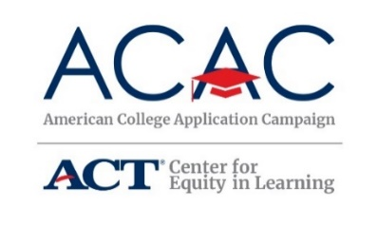

**Building a School UCAW Team**

Utah College Application Week programs held at participating high schools are collaborative initiatives organized by the site coordinator. Leveraging partnerships with community organizations, PTAs, community councils, and other parent or family groups, student clubs or honor societies, teachers, college readiness personnel within your school or district, and local college access groups that serve your area will provide much-needed volunteers, increase success, and generate additional ideas.

The following worksheet provides suggestions of groups to incorporate as you build your team:

UCAW TEAM WORKSHEET

|  |  |  |  |
| --- | --- | --- | --- |
| Potential Partner | Name | Email Address | Phone Number |
| Administration (principal, assistant principal, etc.) |  |  |  |
| School counselors |  |  |  |
| Utah College Adviser (if applicable) |  |  |  |
| School district foundation |  |  |  |
| Student representatives |  |  |  |
| Teacher representatives |  |  |  |
| Title 7 representative (Indian Education) |  |  |  |
| PTA, parent, or community council representatives |  |  |  |
| Chamber of Commerce representative |  |  |  |
| Community non-profit supporting organization |  |  |  |
| Faith-based community representative |  |  |  |
| K-12 or K-16 alliance |  |  |  |
| Local business leaders |  |  |  |
| Mayor’s office |  |  |  |
| Non-profit representative |  |  |  |
| School Board Association |  |  |  |
| Other |  |  |  |
| Access Personnel (may not all be applicable in all districts or all schools) | | | |
| AVID partner |  |  |  |
| GEAR UP |  |  |  |
| TRiO – Talent Search |  |  |  |
| TRiO – Upward Bound |  |  |  |

As outlined above, a school team comprised of a variety of stakeholders is extremely effective in creating support and buy-in for your school’s College Application Week event.

After your College Application Week event, your school team should meet to debrief the successes and challenges of the current year’s initiative. By quickly assessing what worked and what areas need improvement, your school team can get a jump-start on planning for the following year’s program and create an action plan to work with students who still need to finish the college application and financial aid application processes.

Organizing the Application Event

**The Core Class Model**

The most popular model for UCAW is to organize the event around core classes that enroll all high school seniors, usually English, and bring those classes to the computer lab during regular class time to participate in UCAW. For schools with limited computer labs, this means scheduling class lab space throughout the week. This is the easiest model to plan, but be aware of other events that may have recently encroached on core class teachers’ instruction time.

**The Technology Model**

Some schools have enough computer labs, individual laptops, and bandwidth for the entire senior class to be online at the same time filling out applications. Schools will still need to designate a room for students using laptops and staff those rooms with teachers, counselors, or volunteers who are familiar with the application process to help answer questions. Using this formula, a high school may be able to schedule all seniors to complete an application in a single day or half-day, depending on school size.

**The Non-Core Model**

Instead of using core classes, some schools have used citizenship/government classes for College Application Week since a well-educated citizenry is the foundation of American democracy. Keep in mind that not all seniors are in this half-year class during the fall. Schools that use this model have identified students that were not in the citizenship/government courses and checked them out of another non-core class to participate.

**The Hybrid Model**

Some schools, for example, Provo High School, distribute a short survey to their seniors, asking them to identify the top schools where they wished to apply. Provo High then checked out students based on the institution they were applying to and sent them to the appropriate computer lab. For example, all students who were applying to UVU were in the same computer lab at the same time, with a college rep from UVU there to help answer questions. All students who were applying to USU were in the computer lab at the same time with a USU rep there to offer additional assistance. Having all students fill out the same application at the same time contributed to some group troubleshooting. This method takes more planning and preparation hours but ran very smoothly.

**Optimizing Resources Model**

San Juan is a rural district with a lot of square mileage and five high schools. Their College Application Week team consisted of individuals from the district and from the USU-Blanding campus. This team spent one day at each high school for a week assisting students in filling out applications. Due to their small class size and large distances between schools, this method helped each high school maximize its resources. The district and USU-Blanding were able to equally support the schools by traveling to each one on a designated day.

COVID-Friendly Distance Learning Model

Given the rise of the pandemic in 2020, many schools implemented UCAW through distance learning. Schools have created a self-directed Canvas course, and others have created a page on their school counseling site for their event. Schools may also consider directing students to the Keys to Success App to help students explore colleges. Social distanced events may be possible, so please follow your district and school policy.

Additional Resources

American College Application Campaign

[acac@act.edu](mailto:acac@act.edu)

equityinlearning.act.org/acac/resources/site-coordinator-materials

Utah College Application Week

Utah System of Higher Education

[ushe.edu/utah-college-application-week](https://ushe.edu/utah-college-application-week/)

[ucaw@ushe.edu](mailto:ucaw@ushe.edu)

[lisa.molina@ushe.edu](mailto:mmartinez@ushe.edu)

Keys to Success

[ktsutah.org/ucaw](https://www.ktsutah.org/ucaw)

Georgia Apply to College Materials

University System of Georgia

[usg.edu/apply-to-college](http://www.usg.edu/apply-to-college/)

Go On, Idaho! Statewide FAFSA Day

[financialaid.boisestate.edu/timely-tips-archive/goonidahostatewidefafsaday](http://financialaid.boisestate.edu/timely-tips-archive/goonidahostatewidefafsaday/)

Kentucky College Application Week Materials

Kentucky Higher Education Assistance Authority

[kheaa.com/website/kycaw/home](http://www.kheaa.com/website/kycaw/home)

Michigan College Application Week

[micollegeaccess.org/events/college-application-week](http://www.micollegeaccess.org/events/college-application-week)

[micollegeaccess.org/events/college-application-week/site-coordinator-resources](http://www.micollegeaccess.org/events/college-application-week/site-coordinator-resources)

North Carolina College Application Week

College Foundation of North Carolina

[cfnc.org/caw](http://www.cfnc.org/caw)

Oregon College Application Week

Oregon Goes to College

[oregongoestocollege.org](http://oregongoestocollege.org/)

West Virginia College Application and Exploration Week

College Foundation of West Virginia

[cfwvconnect.com/caew.html](http://www.cfwvconnect.com/caew.html)

Section 3:

Pre-Event Awareness & Activities

Best Practices: Creating a College-Going Culture and Preparing Students for College Application Week

Provide activities for ***all students***in your school prior to and during Utah College Application Week. You might organize workshops during student/family pre-college evening events, during homeroom with students, or during the actual College Application Week. You can find templates for some of these activities included in the Appendix. Some topics to focus on include:

* **9th grade**: Decision making, learning styles, study habits, HS transcript and academic planning, connection between school and careers, how to qualify for a scholarship, colleges and the degrees offered, college admission criteria, etc.
* **10th grade**: Progress check, extracurricular activities, earning college credit during high school (AP, IB, Concurrent Enrollment), world of work, college costs and ways to pay, college visits (including online visits), ACT, etc.
* **11th grade**: Money management, finding scholarships, admissions process, college entrance tests, preparing to apply, writing personal statements and essays, etc.
* **12th graders who have already applied to college**: peer-to-peer mentoring during College Application Week, what to expect in college, resume writing, FAFSA, searching for scholarships, finding the right college for you, etc.

**Incorporate College-Focused Activities into the Classroom**

* Ask English teachers if they would be willing to coordinate a **writing workshop** for personal statements or essays. Teachers can go over correct grammar and language to use on a college application. Additionally, stress the importance of using appropriate email addresses (i.e., not hottiegirl1@gmail.com or skoolsucks@gmail.com).
* See if civics, psychology, or social studies teachers will lead a college match lesson where students research and identify schools that are a good fit for their academic records and goals.
* Ask math teachers if they would be willing to do a **lesson on calculating financial need, student loan repayment options, and the return on investment of a college degree**. Investigating average salaries of students who graduate in particular fields is an important piece of the research.
* The US Department of Education Federal Student Aid Office has **grade-level checklists** and research tools to help students become academically and financially prepared for postsecondary education. These checklists and resources can be utilized in classroom preparation activities: [studentaid.gov/resources/prepare-for-college/checklists](http://studentaid.gov/resources/prepare-for-college/checklists)
* **Keys to Success** has state-specific resources to help students prepare for the college application process, such as comparing colleges and exploring careers and majors. These resources can be utilized in the classroom: [ktsutah.org/resources](http://www.ktsutah.org/resources).

**Communicating to Students, Families, Community Organizations**

**College Application Week Folder**

The College Application Week folder has become a popular way to make sure students have all their necessary application information in one place. Event coordinators create a folder for each student with the student’s name, their current transcript, and copies of all UCAW worksheets, informational documents, and the student survey inside, as well as places for students to write down their username and passwords for college or university applications. The folders are theirs to keep and refer to throughout their senior year.

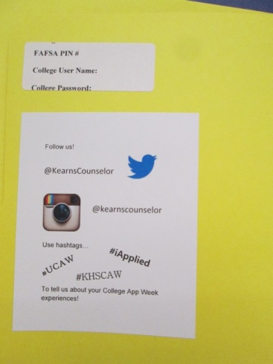

**College Application Worksheet**

Create a list of common information regularly found on college applications so that students can gather the necessary information before applying during UCAW.

**College T-Shirt/Sweatshirt Days**

An easy and fun way to generate some excitement in your school is to host college t-shirt or sweatshirt days. Get everyone involved—all students, staff, and administrators! Many schools host these types of college spirit days for several Fridays prior to the school’s College Application Week or every day during the week preceding the event.

**Involve teachers and staff**

Invite teachers/staff to share their college experience, wear their alma mater gear, decorate their classroom or door with college banners, mascots, or other items, and post signs on classroom doors. Throughout your high school, promote multiple colleges, not one specific university.

**"Ask Me!" Signs**

“Ask Me!” signs are a quick and low-cost way to create awareness and excitement for your school’s College Application Week. Send the “Ask Me!” sign to all staff members in the school, have them customize it, and hang it on the door or the wall outside their classroom or office.

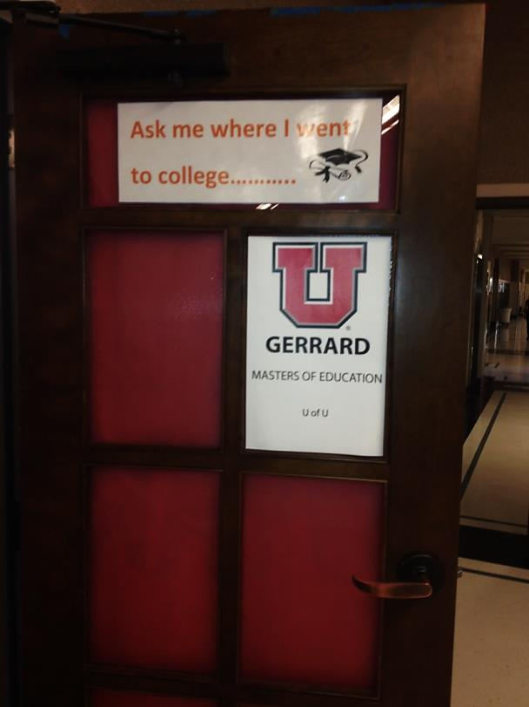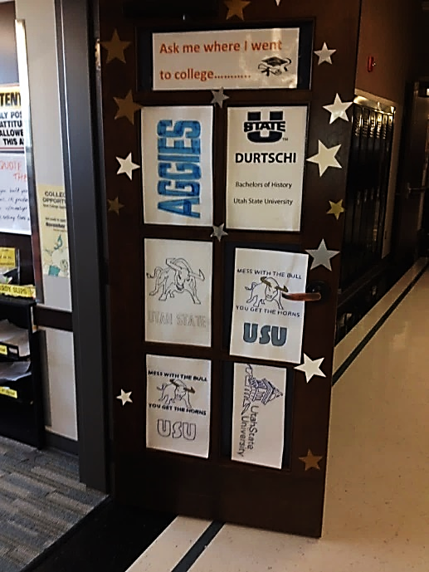

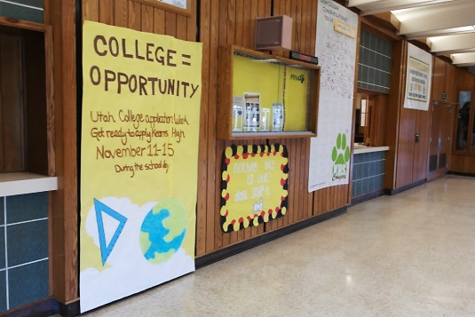

**Morning Announcements**

You can also generate excitement by highlighting different colleges and universities during school announcements in the weeks leading up to your event. Make the announcements exciting by having speakers provide a unique fact about the school, sing the school’s spirit song, or take other creative approaches.

**Informational Letters**

Send letters or postcards to parents and community partners with information and a timeline for UCAW.

**Phone/Email Blast Message**

To ensure students have time to prepare for the event, it is recommended that you send a phone blast to parents at least three weeks prior to the program. Sample message:

“This is a friendly reminder that (Name of High School) will be hosting Utah College Application Week October XX-XX to encourage all seniors to apply to at least one college, if they haven’t already done so. Students should come to school that week knowing where they want to apply and should be prepared to fill out a college application by bringing the necessary information like ACT scores and their Social Security Number. Please reach out to our [job title of person overseeing UCAW] at [contact information] to answer any questions.”

**School Newspaper**

Enlist the yearbook staff or school newspaper writers to interview seniors about their college plans and publish these interviews in the school paper. Post graphics or ads in the school newspaper or create a special section in the school newspaper talking about College Application Week.

**School District Awareness & Possible Financial Support**

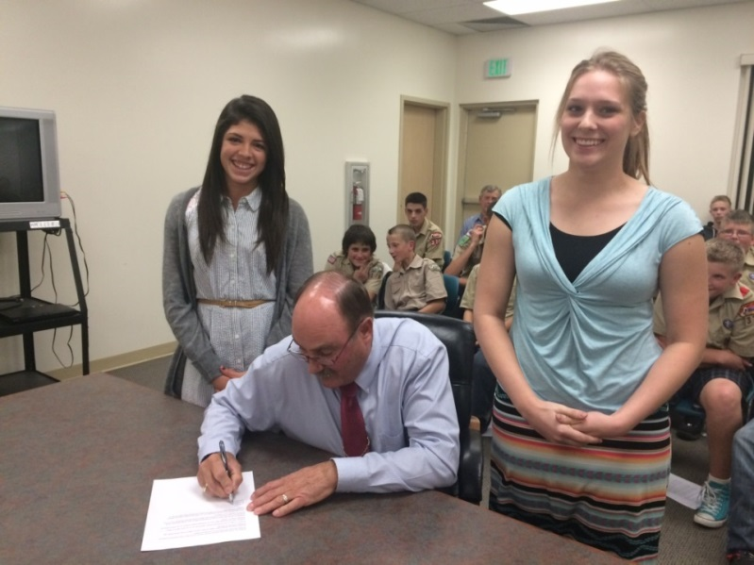**You may want to ask your school district foundation to set aside some funds to help high-need students pay college application fees.** Additionally, a district-wide proclamation of UCAW can spread awareness throughout the community and the elementary and junior high/middle schools.

*Granstville Mayor Brent Marshall signing a* *Utah College Application Week proclamation**.*

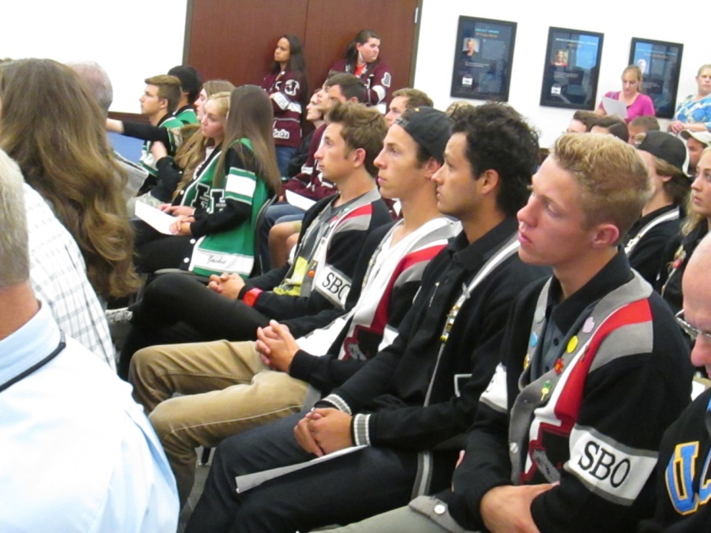

**School Website**

Use your school’s website to communicate the opportunity to participate in Utah’s College Application Week to students, their families, and the community. In addition to adding your College Application Week to your school calendar, be sure to include pre-event activities on the calendar as well. Use your website to post any materials that you want students and their families to have access to prior to your event.

**Senior Canvas Course**

Use your school’s Canvas portal to create a one-stop-shop for all seniors to access throughout the month of October and throughout the year. In addition to information about Utah colleges (degree-granting and technical colleges), post information on scholarships, FAFSA, and other resources that are pertinent to the student demographics. If your school has a college adviser, you may consider including them in the creation of this canvas course.

**Utah College Application Week Poster**

Hang these posters throughout your campus to bring awareness to all students that Utah College Application week occurs during the month of October. Invite seniors to participate during your school’s UCAW dates and engage on social media by using #**#UCAW, #CollegeBound** and **#iApplied.**

Section 4:

Media and Public Relations

Utah College Application Week Media Information and Guidelines

As a statewide campaign, USHE is able to gain public support and momentum through strategic public relations, press releases, and communication. Coordination of local and statewide media generates support and awareness from government, businesses, and the community.

Individual schools and districts are welcome to contact and speak with the media regarding their College Application Week events. Please make sure to follow district or LEA media policies and rules. Suggested press release verbiage is in the Appendix; we ask that schools include this information in any communications with media.

**Photo/Video Release Forms**

If you are planning to use a student’s likeness via photo or video images, please follow your district or LEA guidelines on photo release forms and keep them on file.

**Local Press Releases**

Contact your local media to inform them of your College Application Week. If school policy allows, invite them to cover your program. Media coverage will help students, families, and the community recognize the importance of this program for your school and students. If your school or district has a public relations specialist, utilize them to draft your press release and send it to the proper outlets.

**Mayoral Proclamations**

USHE will work with the Governor’s Office to proclaim October Utah College Awareness & Application Month. A mayoral proclamation for your city is a wonderful complement. If there are multiple schools in your city limits implementing an event, be sure to coordinate with them so the proclamation is accurate and reflects all participating schools. A sample proclamation is included in the Appendix.

**Social Media**

Social media is one of the easiest and quickest ways to share information. It is helpful to create posts ahead of time that include the UCAW hashtags, so you can encourage students to use their own social media accounts to share the event with their friends. Pre-selected hashtags are #UCAW, #whyapply, and #iApplied; hashtags help brand the UCAW campaign, make those messages searchable, and group them online to identify whether they are trending. Follow @USHECounselor on Twitter.

Sample Social Media Posts

Facebook: Post multiple times a week leading up to important dates and deadlines. It is important to post items that will engage the audience and encourage them to participate in the conversation. Open-ended questions and asking for opinions are good ways to initiate dialogue. Include photos when possible to illustrate the success of your event.

**Twitter:** Twitter has a limit of 280 characters per post. To leave space for users to retweet your post and add a comment, try to keep them to 140 characters or less. Use the recommended hashtags **#UCAW, #CollegeBound**, and **#iApplied** will help with branding and searchability. Include photos when possible. Encourage students to use these hashtags as well. **Follow @USHECounselor and @higheredutah on Twitter**

**Twitter Examples:**

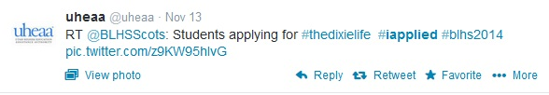

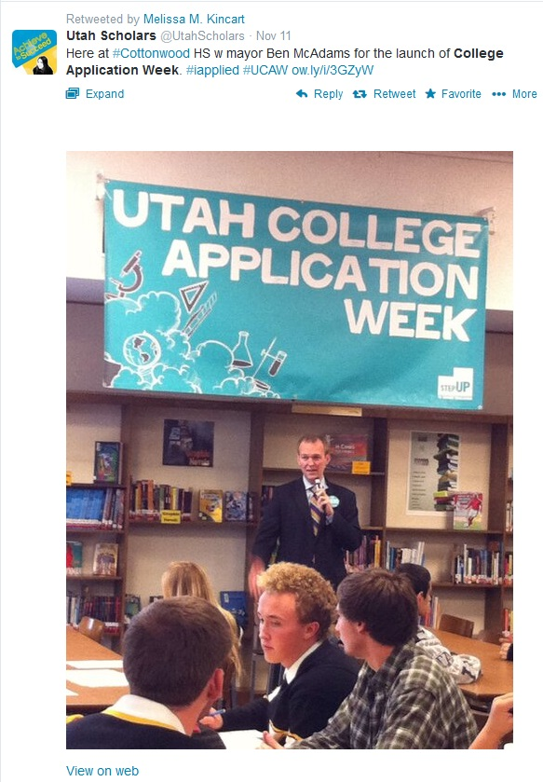

**Instagram Examples:**

Use hashtags **#UCAW, #CollegeBound** and

**#iApplied**. Encourage students to post photos

and use these hashtags as well.

Media/PR Tips

In accordance with your respective district/LEA’s media policy:

**Media**

If the media contacts you to do a story, or if they agree to film any UCAW assemblies or activities:

* Send them to the public relations/communications professional at your district/LEA, if applicable ([schools.utah.gov/schoolsdirectory](https://schools.utah.gov/schoolsdirectory); and here for districts: [schools.utah.gov/schooldistricts](https://schools.utah.gov/schooldistricts)).
* Contact Trisha Dugovic, Utah System of Higher Education Director of Communications, at [tdugovic@ushe.edu](mailto:tdugovic@ushe.edu).

If you are reaching out to the media by press release or other action:

* Make sure that the public relations/communications professional at your district/LEA is involved, if applicable
* Follow all current school district media protocol
* Copy Trisha Dugovic on all press releases or other actions (tdugovic@ushe.edu)

**Press releases**

We suggest that the following paragraph is used at the bottom of press releases:

**About Utah College Application Week**

Utah College Application Week (UCAW) gives every high school senior in participating schools the opportunity to apply to college during the school day. UCAW is coordinated by the Utah System of Higher Education, is part of the American College Application Campaign (ACAC) and ACT Center for Equity in Learning, and focuses on first-generation and low-income students who are less likely to apply to and enroll in college.

Section 5:

During Utah College Application Week

Update: Utah College Application Week Collateral

Although in years past, the Utah System of Higher Education has provided UCAW collateral such as buttons and stickers, we are no longer able to provide these items due to funding. **However, we encourage schools to still utilize any “Ask Me about College” buttons you have recycled for volunteers this year.** Buttons are for volunteers and school staff to **use annually and identify them as a resource** to students during your College Application event.

**Schedule of Events**

To keep your school team, administration, teachers, other staff, and volunteers on the same page throughout your College Application Week event, we recommend printing out and distributing a detailed schedule of what will be happening where and when in your school.

**Student Instructions on Day of Event**

The Keys to Success website (<ktsutah.com>) will have a comprehensive UCAW how-to geared towards students. Directing students to this page will give students direct links to the applications of Utah colleges and universities, as well as additional information on required documents, transcripts, financial aid, and scholarships.

**Volunteer Tasks**

Volunteers are an important part of a successful College Application Week. Be sure to follow your district and LEA guidelines on using volunteers in the school. Although familiarity with the college application process is a plus, it is not required for volunteers to have a meaningful experience at a participating high school. Here are a few tasks that volunteers can perform during any given College Application Week event:

* Post directional signs in the school for the event. Good signage is the key to reminding students of the event and getting them to the right place.
* Greet students as they arrive at the computer lab.
* Help students log on to a college’s website portal and begin an application.
* Guide students through the college application process and help answer any questions students may have, regardless of where the student wishes to apply.
* Monitor printers to ensure that any applications that need to be printed remain in order and replenish the paper supply as needed.
* Help students register for the FSA ID after they submit their college application(s).
* Share personal college experiences with students, as requested.
* Instruct each student to complete the evaluation of their UCAW experience.
* Distribute materials to students after they complete their college application(s), such “Next Steps” handout and a reminder to attend the FAFSA Completion event scheduled at the school.
* Congratulate each student on applying to college and encourage them to complete their admission by sending in their high school transcript, test scores, or any other documentation that the college may require.
* Encourage students to share their experience with other classmates.

**Application Fees**

USHE does not have the ability to distribute monies to help low-income students; individual schools or districts are responsible for finding those dollars and formalizing processes for their use. During your site team meetings, you will need to brainstorm and finalize any options for helping low-income students pay for college application fees. In previous years some schools used school district foundation funds; others solicited businesses and community organizations to donate funds to pay application fees. Many sites have loaded donated funds onto a VISA debit card; others have used a school credit card and carefully tracked the charges. Be sure to clear this process with your administration and/or school district.

**Application Fee Matrix and Waivers**

Application fees and fee waiver processes are often updated throughout the summer. If you have registered as a site coordinator, we will provide up-to-date information on fee waivers and application requirements via email by September. **Refer to the Keys to Success website for information related to application fees and waivers:** [**ktsutah.org/ucaw**](https://www.ktsutah.org/ucaw)

**DATA, DATA, DATA COLLECTION**

USHE needs to be able to report back to the Utah Board of Higher Education, the Governor’s Office, and the state legislature, as well as our national partners on how many high school seniors participate in UCAW events across the state. You will also probably want to report to school administrators, the school board, parents, volunteers, and community members about the impact of your program. Data tracking helps both of those efforts.

**College Application Sign-In Sheet**

A sign-in sheet is important to know who participated in your College Application Week efforts and to follow up with students who may have been absent. We recommend **creating an electronic list in Excel** that includes a separate box for First Name, Middle Initial, and Last Name, as well as birthdate (YYYYMMDD), and highlighting students as they check in to the computer lab.

**Information to Share with USHE**

School Name, Address

Free/Reduced Lunch Rate at School (percentage)

Student Participants (grades 9-12)

Size of Senior Class

# of Seniors Who Participated (Checked In)

# of Student Surveys Collected

# of Completed Applications (Student Reported)

# of Transcripts sent during the month of October (Registrar’s office should have this information)

**Utah College Application Event**

Sign-out Sheet

|  |  |  |
| --- | --- | --- |
| **Student’s First and Last Name** | **Student ID #** | **What colleges did you apply for today?** |
|  |  |  |
|  |  |  |
|  |  |  |
|  |  |  |
|  |  |  |
|  |  |  |
|  |  |  |
|  |  |  |
|  |  |  |
|  |  |  |
|  |  |  |
|  |  |  |
|  |  |  |
|  |  |  |
|  |  |  |
|  |  |  |
|  |  |  |
|  |  |  |
|  |  |  |
|  |  |  |

Section 6:

Post Event and Follow Up

# After Your College Application Program

**Team Debrief**

As noted on the timeline and checklist included in this manual, it is important that your school team meet after the College Application program to discuss what worked and identify areas for improvement. This time can also be used to share first impressions of the results of your program. Use the student sign-out sheet to understand the number of students who applied to college and the number of applications that were submitted. During this debrief meeting, the school team should identify a plan to follow up with participating students to ensure they complete the application process (by submitting transcripts, test scores, application fees, etc.), and that they submit a completed FAFSA. School counselors, AVID, GEAR UP, or TRiO advisers should follow up individually with students, ensure all application fees have been paid and transcripts are submitted to colleges and universities.

**FAFSA Completion**

All students should have an FSA ID after College Application Week; talk with students and families about the importance of FAFSA completion, notify them of FAFSA completion events in your area, and offer any other assistance necessary. This includes giving all students additional information on [H.B. 144](https://educate-utah.org/) and their options outside of federal financial aid.

**Please refer to the FAFSA Night Coordinator Manual for additional information.**

**Volunteer Thank you Letters**

It is important to recognize the time, energy, and effort that volunteers and staff contributed to your school’s College Application Week event. A template thank you letter has been provided. Feel free to print this on school letterhead and mail it. Or, if you would like to send by email, that is a great way to show your appreciation as well.

**Post-Event Press Release**

You notified your community that the event was coming up—now make sure you communicate about the success of your program! Use the post-event press release template in the Appendix to update your local media about the impact of your program.

**May: College Decision Day Activities**

The end of a students’ senior year is often centered on celebrating their graduation from high school. Decision Day is intended to also celebrate their decision to attend an institution of higher education. While National College Decision Day is May 1, any time in May would be appropriate for this activity. It is easy to honor every senior’s postsecondary plans, whether that includes a 2-year or 4-year college degree, military or religious service, or a technical certificate.

Ideas for College Decision Day:

* Have a large school-wide event, inviting student groups from the local college or university to talk about First Year programs and what it’s like to be a student.
* Organize a College Decision Day assembly.
* Have a large carnival-type celebration with activities and games and a dunk-tank for the school administration.
* Keep things casual by having a quick morning or lunchtime event, where you invite seniors, their parents, underclassmen, faculty, and counselors to mingle in the cafeteria for 30-45 minutes. Hosting this event in the morning, prior to 1st period, won’t interfere with many events, and working parents can stop in on their way to the office. Doughnuts, bagels, muffins, juice, and coffee make it a celebration without spending too much money. Invite the principal to say a few quick remarks about how proud he/she is of the seniors and all their wonderful accomplishments.
* Encourage students and faculty to wear college t-shirts, college colors, or other college gear.
* Hang up a picture of each senior and include their postsecondary plans and perhaps also a quote, yearbook-style. Or have seniors fill out a blank pennant with their name, their college, and any major or career plans.
* Play college fight songs at a table where students can write thank-you notes to teachers or faculty who have helped with their college applications.
* Have a photo wall backdrop where students can take pictures to upload to Facebook, Twitter, or Instagram and encourage the use of the hashtag #DecisionDay.
* Create a bulletin board or wall map with names of students and where they are going to college, for example, “Where is the Class of 2020 Going?”

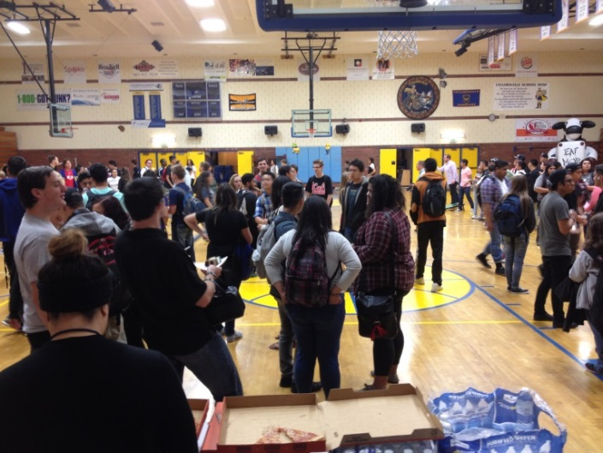

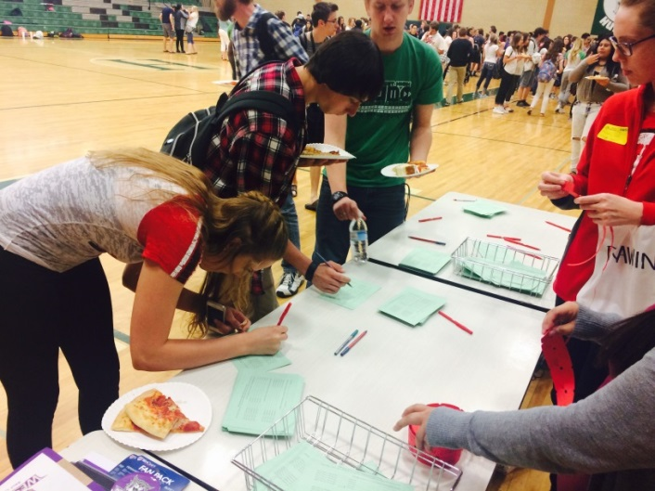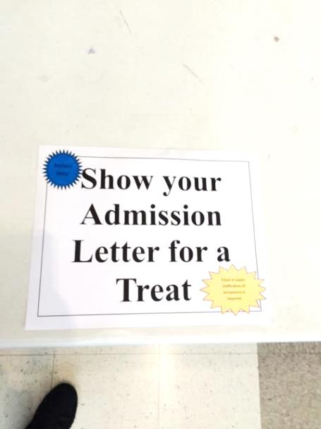

Social Media Surrounding National Decision Day

Post multiple times a week on your social media channels leading up to important dates and deadlines. It is important to post items that will engage the audience and encourage them to participate in the conversation. Open-ended questions and asking for opinions are good ways to initiate dialogue. We recommend using the hashtags **#DecisionDay** and **#reachhigher** to help brand your campaign and make messages related to Utah College Application Week searchable online. Include photos, when possible, to illustrate the success of your event.

**Sample social media posts:**

* You’ve taken the ACT, and you’ve filled out the FAFSA; now your hard work is about to pay off! College #DecisionDay is May 1. We can’t wait to hear where you are going this fall.
* College #DecisionDay is around the corner. What factors will weigh into what college you choose?
* While you’re thinking about who your prom date might be, don’t forget to keep thinking about where you’re going to college this fall. Whether it’s a community college, a 4-year university, or a technical college, you’ve made a big decision to keep learning! #DecisionDay
* May 1 is College #DecisionDay! Join us in congratulating our seniors on this big decision.
* Tomorrow is College #DecisionDay. Show your spirit as we celebrate your future! We are so proud of our seniors.
* Today is the day seniors tell us where they are going to college. Don’t forget to wear your college gear to celebrate. It’s #DecisionDay!
* Seniors! May 1 is College #DecisionDay. Where are you going?
* Congratulations, seniors, on your College Decision Day!
* College #DecisionDay is next week. Remember to wear your #college colors to school.
* It’s Utah’s College #DecisionDay! Show us how you’re celebrating.

Appendix

Student Instructions for Utah College Application Week

Congratulations! You are taking the first step toward going to college—applying! Utah College Application Week is a program designed to assist you with this process. Please remember that there are several things you will need to do after today to complete the college application process:

**Step 1:** If you are applying online, go to the college application website and find the colleges to which you want to apply. This could be a website with multiple college applications or the website of the college(s) to which you are applying. Check with your school counselor or volunteer if you are unsure. If you are not applying to college online, get a hard copy of the admissions application from your school counselor.

**Step 2:** If you think you qualify for an application fee waiver, talk to your school counselor.

**Step 3:** Complete the application(s) to the colleges and universities to which you want to apply.

**Step 4:** Make note of any additional items you need to submit with your application (essay, transcripts, SAT or ACT scores, recommendation letters).

**Step 5:** Print out a copy of your confirmation page if you applied online. If you are applying through a paper application, talk to your school counselor about how to make a copy of your application. Keep the confirmation page or a copy of the application for your records.

**Step 6:** Register for your FSA ID. You will need this to complete your Free Application for Federal Student Aid (FAFSA) as soon as possible! Many grants, loans, and scholarships will require that you submit a FAFSA, so this is a very important step. Go here to register for your FSA ID: [fsaid.ed.gov/npas/index.htm](https://fsaid.ed.gov/npas/index.htm). REMEMBER YOUR FSA ID! Write it down to help you remember it and keep it in a safe place.

**Step 7:** Be sure to submit the Utah College Application Week student survey. Your feedback is extremely important to us.

**Step 8:** Complete the student sign-out sheet before you leave the computer lab. You will need to list the colleges you applied to and whether you completed the FSA ID process.

**Step 9:** Be sure to get the handouts or other material provided by your school after you sign out.

**Step 10:** Follow-up! Make sure you submit any additional information the colleges you applied to require. Colleges could require could recommendation letters, test scores, and high school transcripts. Also, the next important step in the process is completing your FAFSA. Now that you already have your FSA ID, sit down with your parents/guardian to submit the FAFSA. Or ask your counselor about any FAFSA Completion Open Houses taking place at your school.

**Congratulations! You are on your way!**

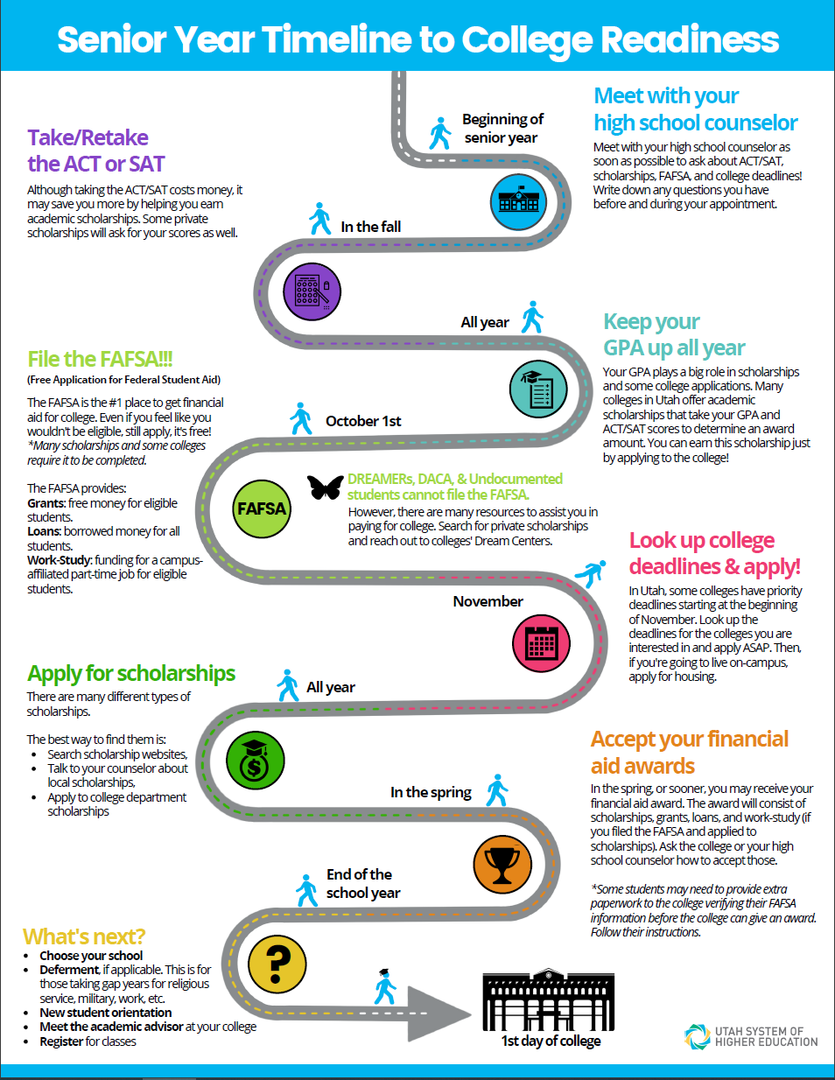

**College Deadlines**

|  |  |  |  |
| --- | --- | --- | --- |
|  | **Incoming Freshman Should…** | | |
| **College Name** | **Apply For Admission By:** | **Submit FAFSA By:** | **Scholarship Application By:** |
| Bridgerland Technical College  *btech.edu/students/financial-aid*  *435-753-6780* | YEAR-ROUND | YEAR-ROUND | FEB 28 (YEARLY) |
| Brigham Young University  *enrollment.byu.edu/financialaid*  *801-422-4104* | Priority: Nov 1, 2021  Final: Dec 15, 2021 | DEC 15, 2021 | DEC 15, 2021 |
| Davis Technical College  *davistech.edu/financial-aid*  *801-593-2195* | YEAR-ROUND | YEAR-ROUND | YEAR-ROUND (FAFSA Required) |
| Dixie Technical College  *dixietech.edu/HTML/pages/students/financial-aid/financial-aidinfo.html*  *435-674-8400* | YEAR-ROUND | YEAR-ROUND | YEAR-ROUND |
| Dixie State University  *financialaid.dixie.edu*  *435-652-7575* | YEAR-ROUND | JUNE 1, 2022 | MAR 1, 2022 |
| Ensign College  *ensign.edu/financial-aid*  *801-524-8111* | AUG 1, 2022 | YEAR-ROUND | NOT APPLICABLE |
| Mountainland Technical College  *mtec.edu/financial-aid*  *801-753-6282* | YEAR-ROUND | Priority: May 1, 2022 | Individual Scholarship deadlines are located at:  *https://mtec.edu/scholarships/* |
| Ogden-Weber Technical College  *otech.edu/future-students/financial-aid*  *801-627-8327* | YEAR-ROUND | YEAR-ROUND | YEAR-ROUND |
| Salt Lake Community College  *slcc.edu/financialaid*  *801-957-4410* | AUG 20, 2022 | Priority: April 15, 2022 | FEB 1, 2022 |
| Snow College  *snow.edu/offices/finaid/index.html*  *435-283-7129* | AUG 20, 2022 | JUNE 1, 2022 | MAR 1, 2022 |
| Southern Utah University  *suu.edu/finaid*  *435-586-7735* | Priority: May 1, 2022 | Priority: May 1, 2022 | MAR 1, 2022 |
| Southwest Technical College  *stech.edu/admissions/financial*  *435-586-2899* | YEAR-ROUND | YEAR-ROUND | YEAR-ROUND |
| Tooele Technical College  *tooeletech.edu/future-students/financial-information/financial-aid*  *435-248-1800* | YEAR-ROUND | YEAR-ROUND | 15TH OF EACH MONTH |
| Uintah Basin Technical College  *ubtech.edu/admissions/scholarships-financial-aid*  *435-725-7100* | YEAR-ROUND | YEAR-ROUND | YEAR-ROUND |
| University of Utah  *financialaid.utah.edu*  *801-581-6211* | DEC 1, 2021 | Priority: Feb 1, 2022 | NOT APPLICABLE |
| Utah State University  *usu.edu/financialaid*  *435-797-0173* | YEAR-ROUND | YEAR-ROUND | January 10, 2022 |
| Utah Valley University  *uvu.edu/financialaid*  *801-863-8442* | AUG 1, 2022 | Priority: April 1, 2022 | MAR 1, 2022 |
| Weber State University  *weber.edu/financialaid*  *801-626-7569* | DEC 1, 2021 | APRIL 1, 2022 | NOT APPLICABLE |
| Westminster College  *westminstercollege.edu/financial-aid*  *801-832-2500* | Priority: Dec 1, 2021 Rolling after Dec. 1 | YEAR-ROUND | YEAR-ROUND |

**F****AFSA Night Survey Code**

**UCAW Survey**

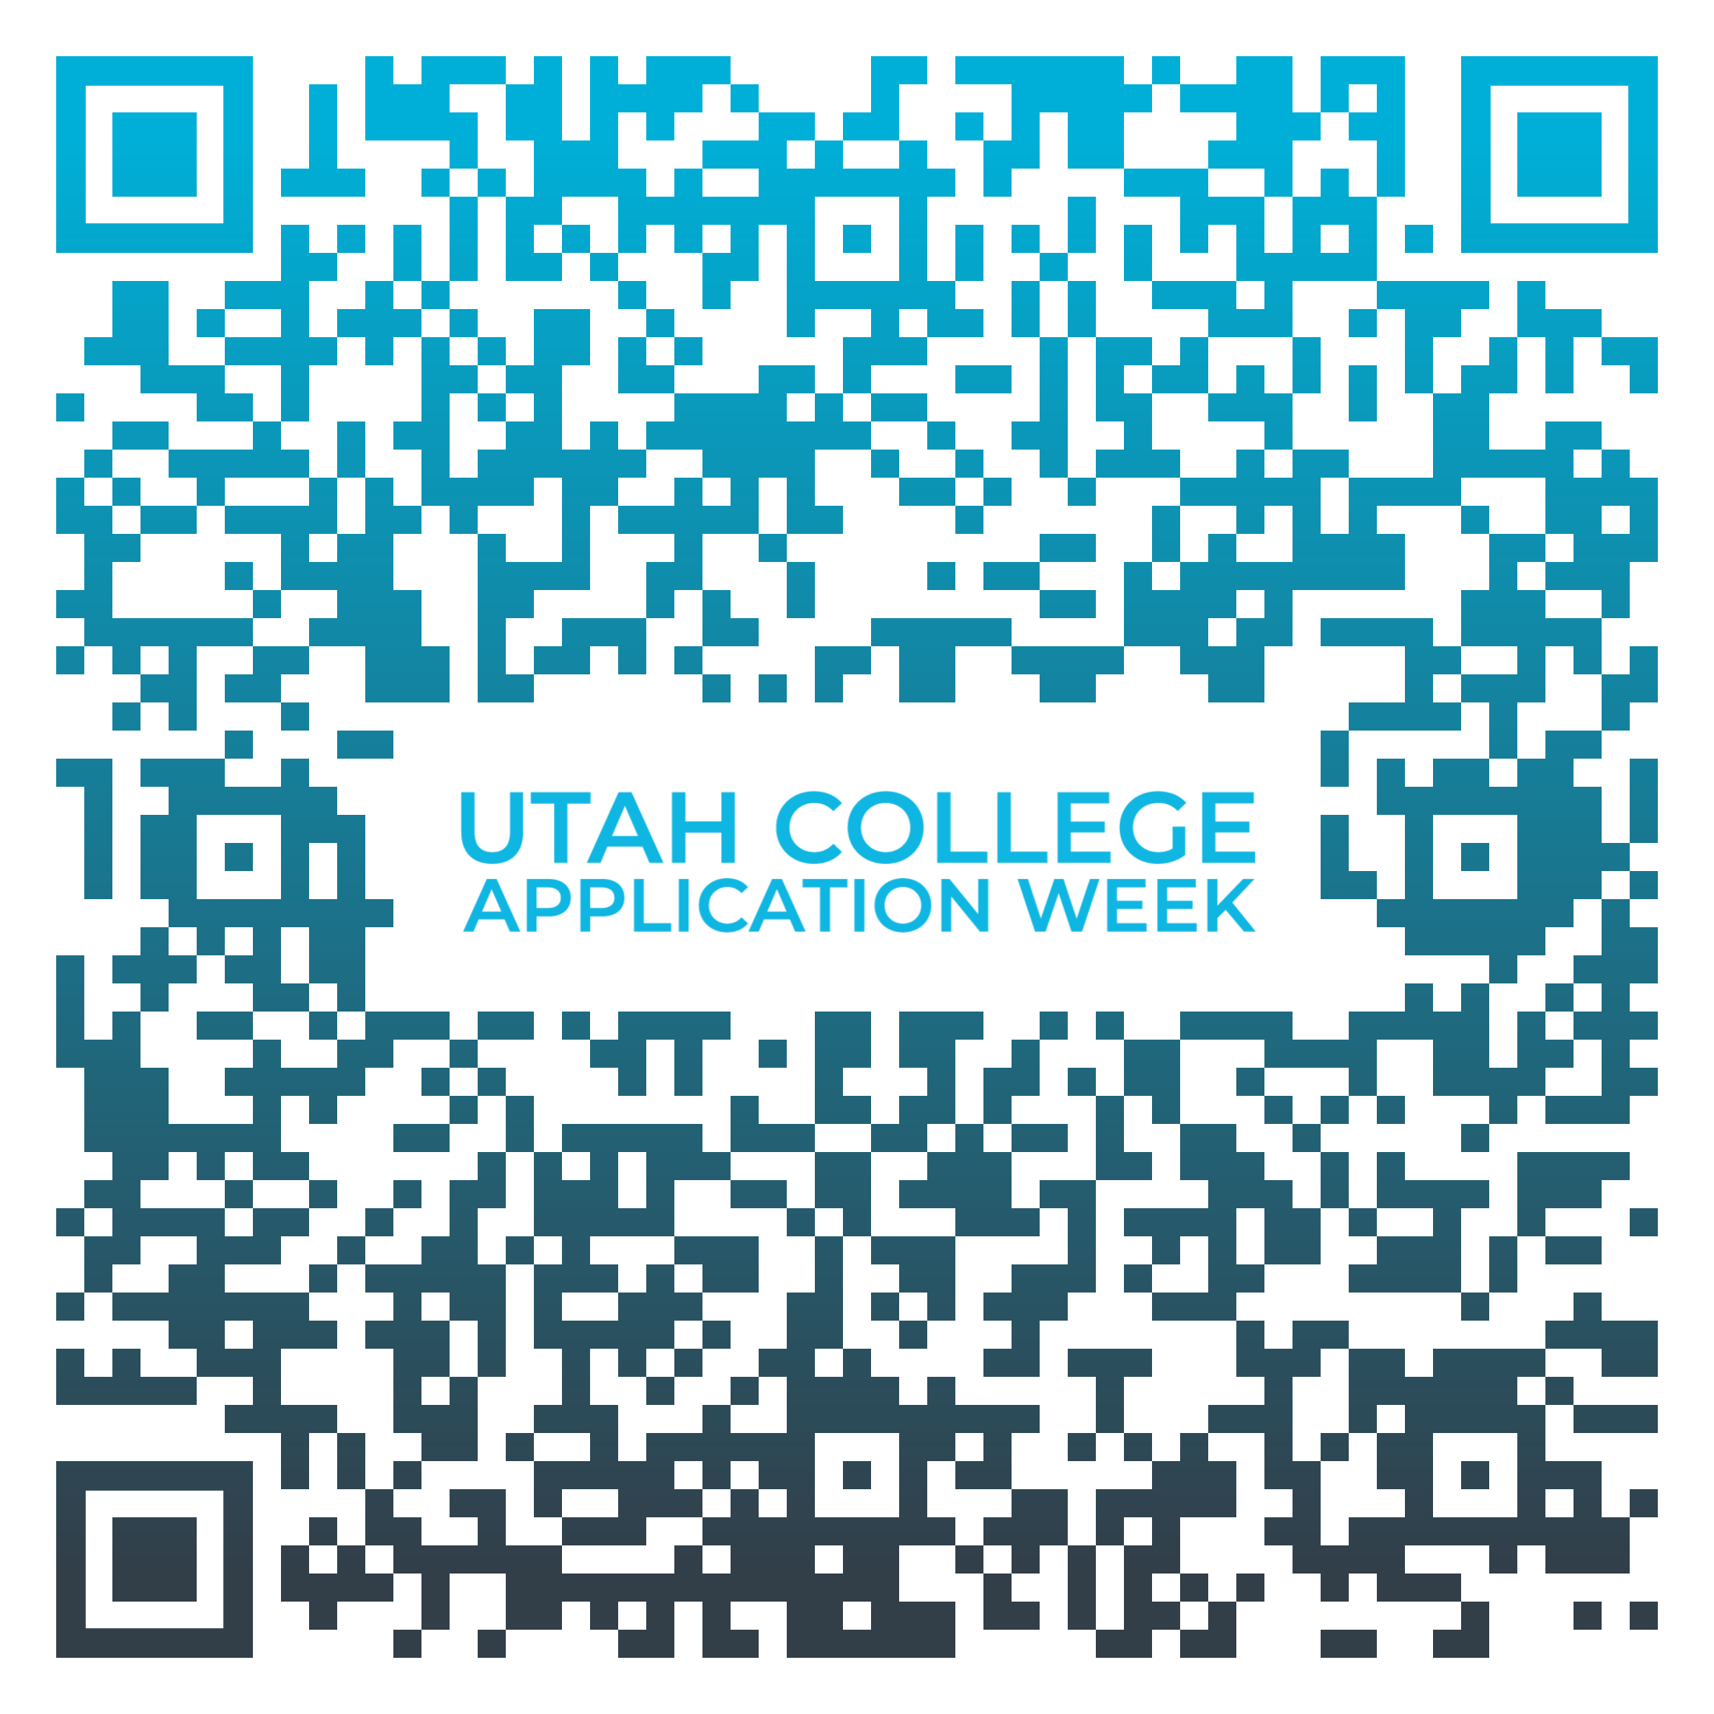

**FAFSA FSA ID Registration**

Go to [fsaid.ed.gov](http://fsaid.ed.gov/) and select “Create an FSA ID.”

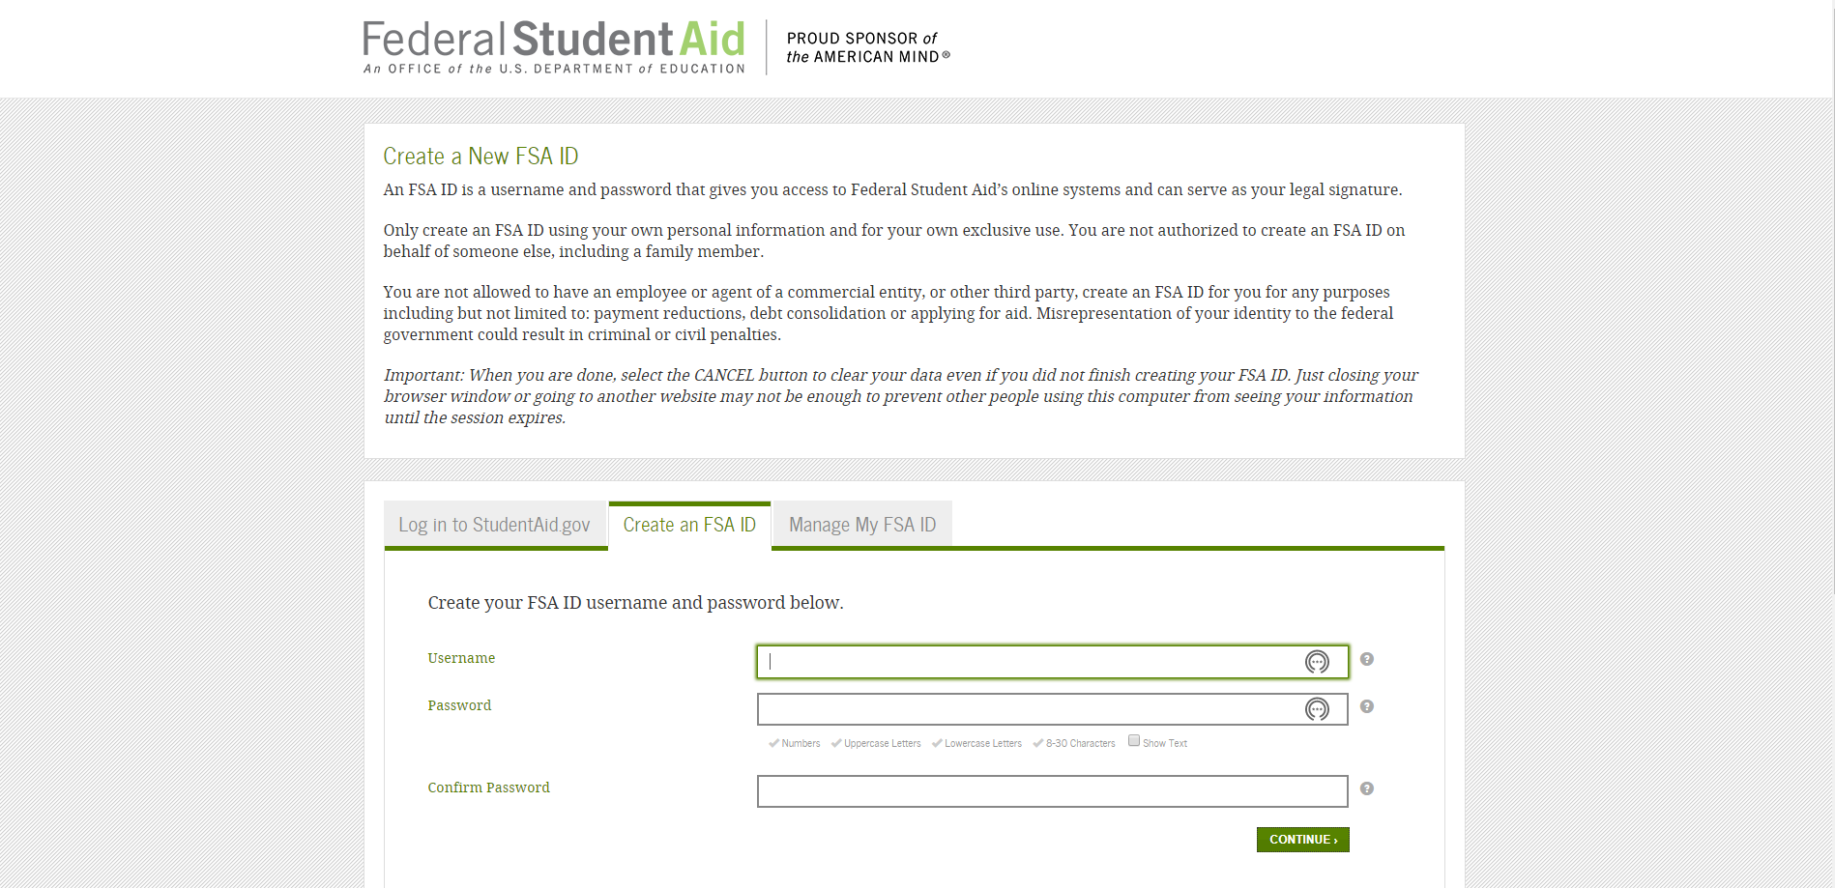

* Since you will use your FSA ID in the years to come, use a permanent email address (**not** your school email address)
* Remember your information
  + Username:
  + Password:
  + Email Address:
  + Other Info:
* Need more help? Ask your school counselor for more information about the FAFSA process!



**OCTOBER (add dates here) 2021**

**#UCAW**

**#CollegeBound**

**#iApplied**

**Apply to college during the month of October**



Add Your HS Logo Here

Ask me about

**October X –X, 2021**

I graduated from…

**________________________________**

**(Add college or university mascot or logo)**

College BINGO Activity

Complete your BINGO card by locating teachers or other school staff members that experienced the following college scenarios or if you can answer “yes” to the following questions. Be sure to get the individual to sign in the space. You can only use each person for one space!

|  |  |  |  |  |
| --- | --- | --- | --- | --- |
| **B** | **I** | **N** | **G** | **O** |
| Attended a 4-Year College | Lived at Home While Attending College | Worked Full-Time While Attending College | Is Still Close Friends with His/Her College Roommate | Studied Abroad While in College |
| Attended a College in Michigan | Went to College on a Scholarship | Changed Majors 2 or More Times | Attended a 2-Year College | Majored in Math |
| Majored in Science | Attended an Out-of-State College | **FREE SPACE** | Worked for the School Newspaper, TV Station, or Radio Station in College | Met His/Her/ Their Partner in College |
| Lived on Campus | Is Currently Enrolled in a College Program or Course | Had a Mentor or Other Close Adviser in College | Was President or Leader of a School Club | Has Completed Graduate School |
| Attended 2 or More Colleges | Wishes They Were Still in College | Ate Ramen Noodles Several Times a Week While in College | Played Sports in College | Took Out Student Loans to Pay for College |

Online Scavenger Hunt

**Colleges and Universities in Utah**

1. List the names of five public colleges and universities in Utah and where they are located.

____________________________________________________________

____________________________________________________________

____________________________________________________________

____________________________________________________________

____________________________________________________________

1. Find the name of the college where students and alumni are referred to as “Aggies.”

What is the name of the college? ____________________________________________

Where is it located? ______________________________________________________

1. What college or university has a wolverine for a mascot?

What is the name of the college? ____________________________________________

Where is it located? ______________________________________________________

1. What is the name of the oldest college in the United States? Where is it located?

What is the name of the college? ____________________________________________

Where is it located? _______________________________________________________

1. What is the name of the oldest university in Utah, and where is it located?

What is the name of the college? ____________________________________________

Where is it located? ______________________________________________________

1. Which college newspaper in Utah is the longest-running? What is it called?

____________________________________________________________

1. Dixie State University had four other names before settling on its current name. What were two of the previous four names of the university?

Other name #1: ___________________________________________________________

Other name #2: ___________________________________________________________

1. Where did Alan Kay, the computer scientist credited with the concept of the laptop computer, attend college? Where is that college located?

What is the name of the college? ____________________________________________

Where is it located? ______________________________________________________

1. J. Willard Marriott, founder of the Marriott International hotel chain; Robert Dotson, former CEO of T-Mobile; Alan W. Stock, former CEO of Cinemark; and Dee Hock, creator of the VISA credit card all attended the same Utah university.

What is the name of the university? ____________________________________________

Where is it located? _______________________________________________________

1. Name at least two colleges in rural Utah.

First college: ____________________________________________________________

Second college: __________________________________________________________

1. What is a private college or university? Write the definition.

____________________________________________________________

____________________________________________________________

1. What is a public college or university? Write the definition.

__________________________________________________________________

__________________________________________________________________

1. Name the largest private college in Utah. ____________________________________________
2. List one possible college major: ____________________________________________________
3. List the name of two colleges in Utah that offer degrees in that major.

First college: ____________________________________________________________

Second college: ____________________________________________________________

1. Find a college in Utah where you can train to be a paramedic.

What is the name of the college? _________________________________________________

Where is it located? ____________________________________________________________

1. Find a police academy in Utah: ____________________________________________________

Student Interest Survey

The following forms can be given to seniors to determine which schools they are interested in and whether they meet the minimum requirements. See Admission Index. This form is optional and should be used prior to UCAW.

Name:_________________________________________________ GPA:_____________ ACT:_____________

Two colleges you will **FOR SURE** get into:

1. ______________________________________________________________
2. ______________________________________________________________

Two colleges that you **MEET** their admission averages:

1. ______________________________________________________________
2. ______________________________________________________________

Two colleges whose admission averages are **SLIGHTLY HIGHER** than your own:

1. ______________________________________________________________
2. ______________________________________________________________

If you are looking for a certificate, trade, or vocational training, list the program you are interested in:

___________________________________________________________________________________________

Are you interested in the military? (circle response) YES NO

If yes, which branch: __________________________________________________________________________

Have you already applied to college? If so, which one(s)? _____________________________________________

___________________________________________________________________________________________

___________________________________________________________________________________________

**College Application Worksheet**

**Instructions:** Students, complete this College Application Worksheet and bring it with you on the day of your school’s college application event. You may need to ask your family, school counselor, or another adult you trust to assist you in answering all of the questions. **Be sure to keep this information in a safe place, given the personal information included.**

**Personal Information**

**Name: _________________________________ Advisory: ________________________________**

**Phone: _________________________________ Email: ___________________________________**

**Social Security Number: __________________ Citizenship Status: ________________________**

**\****If you do not have a social security number or legal residency, please ask a counselor how to complete your college application. There are resident tuition options and scholarship opportunities for undocumented students.*

**Gender: _________________________________ Ethnicity: ________________________________**

**Driver’s License State and Number: ___________________________________________________**

**Emergency Contact Name / Phone / Email:______________________________________________**

**Academics**

**College Choice 1: __________________________________________Application Fee: __________**

**College Choice 2: __________________________________________Application Fee: __________**

**Intended College Major/Field of Study: _________________________________________________**

**When do you want to start college? __________ High School Graduation Date: _______________**

**ACT Test Score: ___________________________ Cumulative GPA: _________________________**

**Have you taken Concurrent Enrollment? ______ Please list: ____________________________**

**List extracurricular activities or clubs, years participated, leadership positions, and awards, if applicable:**

**__________________________________________________________________________________**

**__________________________________________________________________________________**

**__________________________________________________________________________________**

**List any employment history, the company, your position, and the years employed: __________**

**__________________________________________________________________________________**

**__________________________________________________________________________________**

**Student/Family Information Letter**

(School Logo)

(School Address)

October 2021

Dear students and families,

This fall, we will be helping seniors complete and submit college applications as well as the Free Application for Federal Student Aid (FAFSA). Utah College Application Week (UCAW) combines these two major pieces of college readiness and will provide your student with step-by-step instructions and assistance to complete and submit a college and FAFSA application. On (Date(s) of event), all seniors expected to graduate in 2021 will be encouraged to apply for admission to at least one college or university, if they have not already done so. This event is possible due to the collaborative efforts of the administration, faculty, and staff at (Name of your high school), as well as students, their families, and volunteers across the community. On (Date(s) of event), all seniors and their families are encouraged to attend our FAFSA Completion night to get help submitting their application for financial aid.

The purpose of College Application Week is to acquaint students with the college application process and to communicate the importance of applying to college and for financial aid. There is a College Application Worksheet which we encourage students to complete prior to the event that is available on [provide state’s College Application website or ask schools to post it to their website and include the link here]. Having this worksheet completed and available at the college application event will allow students to quickly and easily complete college applications.

We anticipate that students and their families will need to work together in gathering the information listed in the college application worksheet. Families are welcome to visit (Name of your high school) on (Date(s) of event) to assist their student during the application process. In addition, if family members are interested in volunteering or guest speaking during the event, please let me know. Volunteers can greet and sign in students, assist students with the completion of college applications, or distribute information about financial aid opportunities.

If you have any questions, please call (Site Coordinator’s Name, Site Coordinator’s Title) at (Site Coordinator’s phone number). Thank you in advance for your support of this exciting initiative to encourage all Utah students to make college a part of their future.

Sincerely,

(Name of Site Coordinator)

(Title)

**Community Information Letter**

(School Logo)

(School Address)

October 2021

Dear Community Member,

During October 2021, (Name of your high school) will be participating in Utah College Application Week. On (Date(s) of event), all seniors expected to graduate in 2021 will be encouraged to apply for admission to at least one college or university, if they have not already done so, followed by completing the Free Application for Federal Student Aid (FAFSA). These events are possible due to the collaborative efforts of the administration, faculty, and staff at (Name of your high school), as well as students, their families, and volunteers across the community and the Utah System of Higher Education.

The purpose of College Application Week is to acquaint students with the college application process and to communicate the importance of applying to college, and provide resources and information on how to finance their college education via federal aid, loans, grants, and scholarships.

(Name of your high school) will be hosting our college application event on (Date(s) of event) to assist their student during the application process. We welcome the community to be a part of the program. If you are interested in volunteering or guest speaking during the event, please let me know. Volunteers can greet and sign in students, assist students with the completion of college applications, or distribute information about financial aid opportunities.

If you or your organization would be interested in helping low-income students pay their college application fees, please (provide details for your local educational foundation).

If you have any questions, please call (Site Coordinator’s Name, Site Coordinator’s Title) at (Site Coordinator’s phone number). Thank you in advance for your support of this exciting initiative to encourage all Utah students to make college a part of their future.

Sincerely,

(Name of Site Coordinator)

(Title)

**Sample Parent Email**

**Dear Parents,**

College is the key to your child's future. College can be anything from a one-year certificate to a four-year degree and beyond. And because there are so many kinds of colleges and degrees, college can be a reality for everybody.

October [ ] is College Application Week at **High School Name.** Throughout the week, teachers, counselors, and volunteers will help students get started on the path to college by helping them fill out at least one college application.

This is an amazing opportunity! Please encourage your child to participate and help them do some research on the colleges, degrees, and professions they'd like best.

For more information, visit **(Insert your school website info here)** and StepUpUtah.com.

*Use this card as a parking pass during **DATES** if you would like to participate in any of our activities with your child. *

**Volunteer Thank You Letter**

(School Logo)

(School Address)

(Date)

Dear (Volunteer Name),

On behalf of (Name of Your High School) and our students, I would like to personally thank you for volunteering your time at our Utah College Application Week event. This event could not have been a success without your help and the help of many others who volunteered their time. To improve our future College Application Week events and your volunteer experience, please complete this short online survey at your convenience: [survey link to be emailed to Site Coordinators in the fall.]

During Utah College Application Week, (number of seniors who submitted college applications)seniorssubmitted (number of college applications submitted) college applications. Thanks to our seniors’ hard work and the assistance of volunteers like you, they are one step closer to actualizing their dreams of attending college!

Once again, (Name of Your High School) thanks you for your efforts and contribution of time at our College Application Week! We look forward to seeing you throughout the school year and especially at our event next year.

Thank you!

(Site Coordinator or Principal’s Name)

(Site Coordinator or Principal’s Title)

Sample Mayoral Proclamation

WHEREAS, the college application process may be a barrier to some high school students pursuing postsecondary education due to an absence of information or support, and

WHEREAS, obtaining a postsecondary degree has been linked to higher income, better health, and increased community involvement, and

WHEREAS, (name of city) and (participating high school(s) name) are working to prepare students for the opportunities and challenges of the 21st century, and

WHEREAS, (high school(s) name) is/are part of a statewide initiative, Utah College Application Week, designed to increase the number of students who apply to and enroll in college with a particular focus on first-generation and low-income students

Now, therefore, I, (Mayor’s Name), do hereby declare (Dates of School’s College Application Program(s)) Utah College Application Week in (city) and encourage all seniors to take advantage of the assistance provided through this initiative.

**Sample School Press Release**

(School Logo or Letterhead)

FOR IMMEDIATE RELEASE

Contact: (Name of site coordinator)

(School name)

(School address)

(Phone number)

(Email of contact person)

(High school website)

**Utah College Application Week to be held (Dates) at (Name of High School)**

(Name of Your High School) will participate in Utah College Application Week, coordinated by the Utah System of Higher Education, during October X-XX, 2021.

As part of Utah’s college access initiative, (Name of Your High School) will work with its seniors on (Your School’s Event Dates) to complete and submit at least one college application.

The goal of the program is to get more students applying to Utah’s colleges early in their senior year. During this event, students should be encouraged to apply to any of Utah’s 19 colleges, including 7 open-enrollment public colleges and universities, 3 private schools, 1 research institution and 8 technical colleges, in which they are interested.

(Name of Site Coordinator or School Principal), Utah College Application Week event Site Coordinator for (Name of Your High School), expects more than (Insert Number) seniors to participate with the help of (Insert Number) volunteers from (Insert school staff, administration, college and community resources, and others who are assisting).

The Utah College Application Week initiative is part of the American College Application Campaign (ACAC) and ACT Center for Equity in Learning. Utah joined ACAC/ACT in 2013; in 2014, all states had a College Application Campaign. Utah College Application Week (UCAW) gives every high school senior in participating schools the opportunity to apply to college during the school day. UCAW is coordinated by the Utah System of Higher Education and focuses on first-generation and low-income students.

For more information: (Insert website link or an email address) or

Contact: (Name of Site Coordinator)

Phone: (Site Coordinator’s phone number)

# # #

**Post-Event Press Release**

(School Logo or Letterhead)

FOR IMMEDIATE RELEASE

Contact: (Name of site coordinator)

(School name)

(School address)

(Phone number)

(Email of contact person)

(High school website)

**(YOUR HIGH SCHOOL NAME)’s seniors apply to college during Utah College Application Week.**

(Insert City, Date)—

(Insert Name of Your High School)’s seniors received hands-on assistance applying to college during the school’s College Application Week event held on (Insert Event Date/Dates). Roughly (Insert Number of Participating Students) (Insert name of your high school) students participated in the event held in the school’s (Insert location).

(Insert other details specific to your event, such as the number of volunteers on hand, how students were invited to participate, and/or details on any of the pre-event activities you did).

(Insert quotes from students, parents, volunteers, site coordinator or others).

The Utah College Application Week initiative is part of the American College Application Campaign (ACAC) and ACT Center for Equity in Learning. Utah joined ACAC/ACT in 2013; in 2014, all states had a College Application Campaign. Utah College Application Week (UCAW) gives every high school senior in participating schools the opportunity to apply to college during the school day. UCAW is coordinated by the Utah System of Higher Education and focuses on first-generation and low-income students.

Additional information about the Utah College Application Week program can be found online at <https://ushe.edu/utah-college-application-week/>. For more information about (Name of High School)’s event, please contact (Site Coordinator’s Name) at (Insert Site Coordinator’s phone number) or by email at (Insert Site Coordinator’s email address).

For more information: (Insert website link or an email address) or

Contact: (Name of Site Coordinator)

Phone: (Site Coordinator’s phone number)

# # #

**Adult Photo/Video Release Form**

Date:____________________________

I, the undersigned, being of full and legal age, hereby irrevocably release and authorize my high school and the Utah System of Higher Education and their representatives, successors, or assigns to use, publish and otherwise distribute my name and photographs posed by me for any and all purposes, including advertising, publication, and other purposes of trade, without limitation. No other oral or written representation has been made to me.

#### Contact Information:

_______________________________________________________________________

Name (Printed)

_____________________________________ ______________________________

Email Phone

_____________________________________ ______________________________

Address City / State / Zip

**Photo/Video Guardian Release Form**

Date:____________________________

I, the undersigned, being the parent or legal guardian of ___________________________, hereby irrevocably release and authorize Name of High School and the Utah System of Higher Education and their representatives, successors, or assigns, to use, publish and otherwise distribute my child’s name and photographs for any and all purposes related to Utah College Application Week, including advertising, publication, and other purposes of trade, without limitation. No other oral or written representation has been made to me.

_____________________________________ ______________________________

Child’s Name (printed) Child Signature

#### GUARDIAN’S CONSENT

I am the parent or guardian of the minor named above and have the legal authority to execute the above consent and release. I approve the foregoing and waive any rights on the premises.

_____________________________________ ______________________________

Parent/Guardian Signature Witness

_____________________________________ ______________________________

Email Phone

_____________________________________ ______________________________

Address City / State / Zip